4. Configuring Multi branch Jenkins Pipeline Job

To create and configure a Jenkins Multibranch Pipeline for automatic build execution whenever code is pushed to different Git branches.

Step 1 : Create Python Project

app.py
print("Hello from Jenkins Multibranch Pipeline")
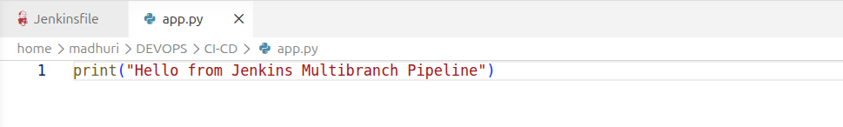

requirements.txt
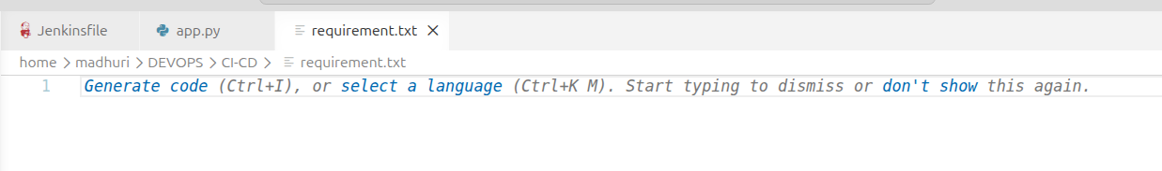

Step 2 : Create Jenkinsfile
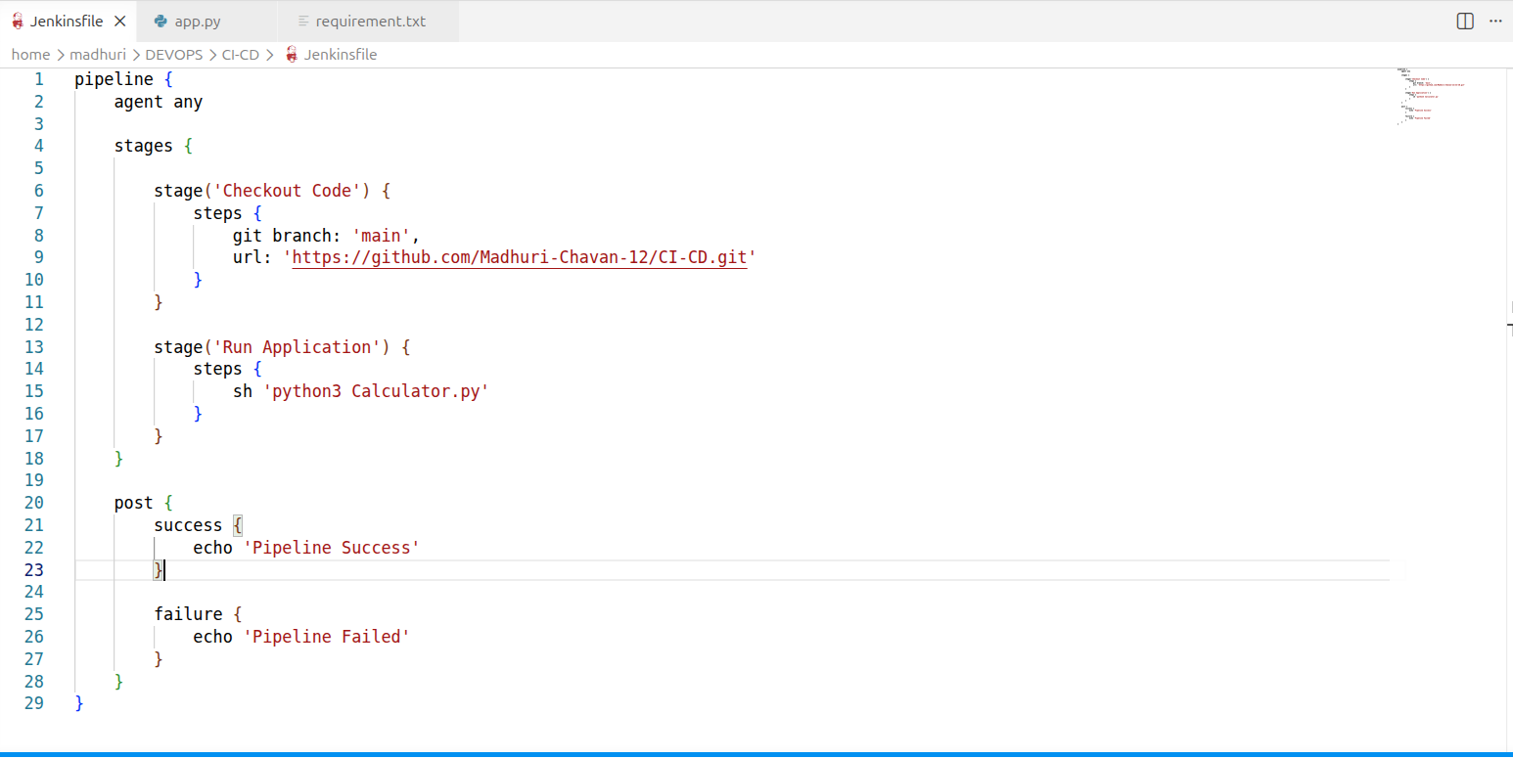

Step 3 : Git Commands
Initialize repository
git init
git add .
git commit -m "Initial Commit"

GitHub repository connect
git remote add origin https://github.com/USERNAME/CI-CD.git
git branch -M main
git push -u origin main
------------------------------------------------------------------------------------------

Step 4 : Create New Branch

git checkout -b dev
Code change
print("Hello from DEV Branch")
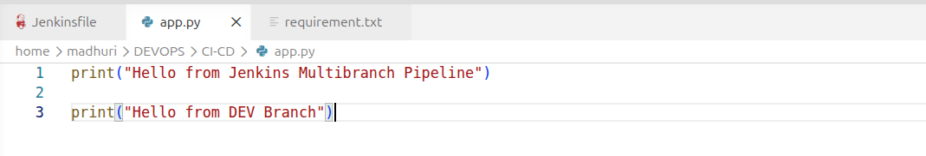
Commit .
git add app.py
git commit -m "Dev branch update"
git push origin dev

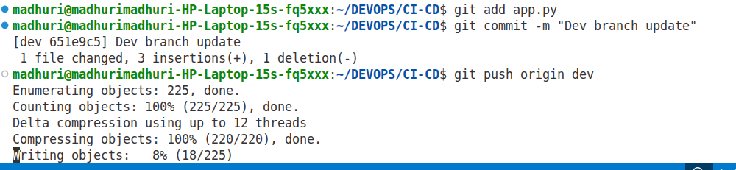

Step 5 : Install Branch Source Plugin
Jenkins Dashboard
Manage Jenkins
↓
Plugins
↓
Available Plugins
↓
GitHub Branch Source

Step 6 : Create Multibranch Pipeline
Dashboard
↓
New Item
↓
Project Name :
Python-Multibranch
↓
Select :
Multibranch Pipeline
↓
OK

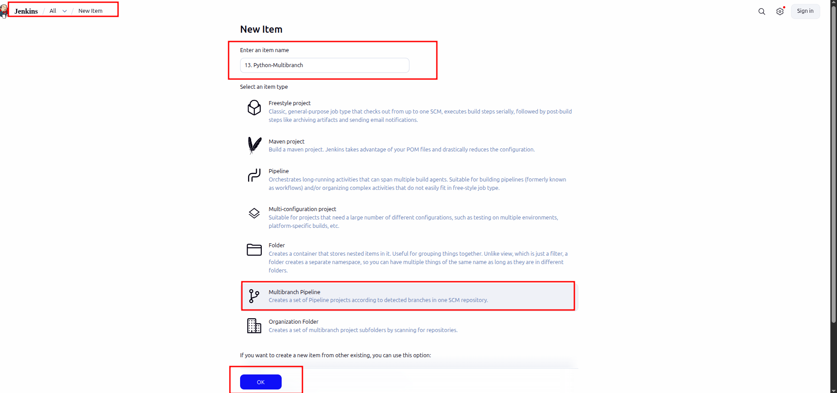

------------------------------------------------------------------------------------------

Step 7 : Configure Repository
Under
Branch Sources
↓
Add Source
↓
Git
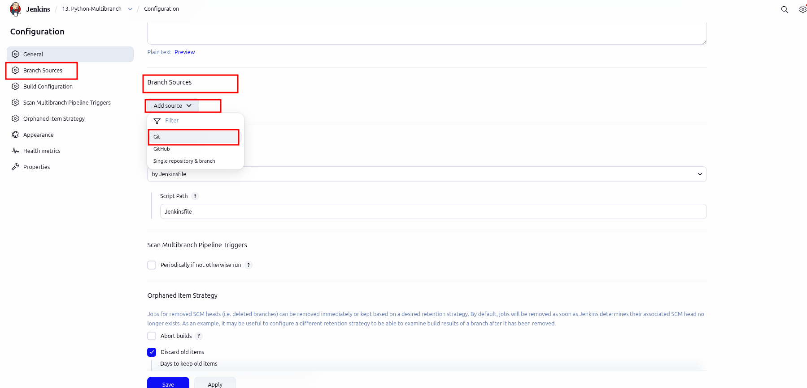
Repository URL:
https://github.com/USERNAME/CI-CD.git
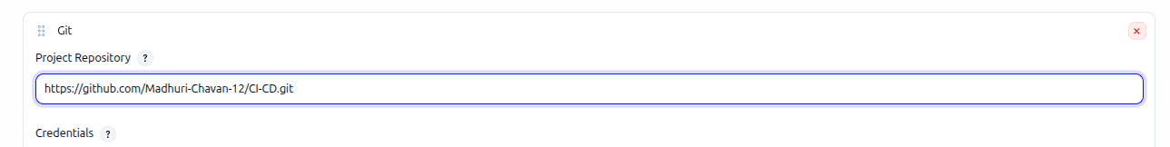

Step 8 : Build Configuration
Build Configuration
↓
Mode :
by Jenkinsfile
Script Path:
Jenkinsfile
Save:
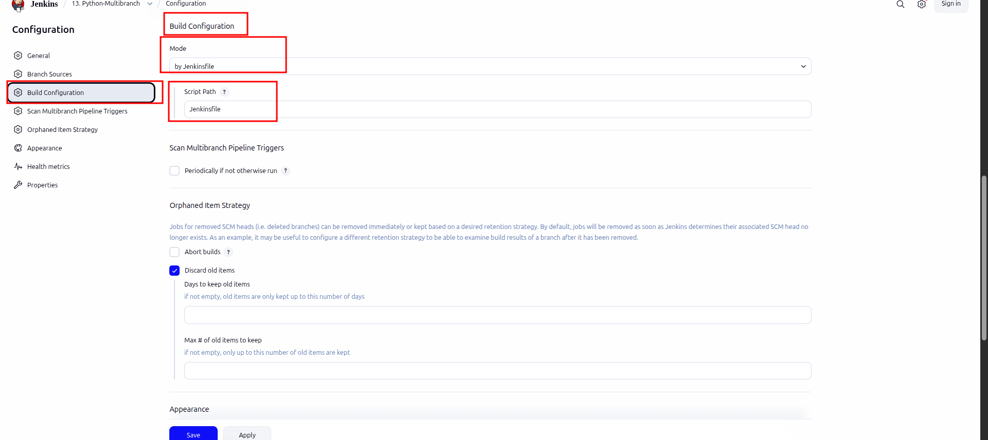

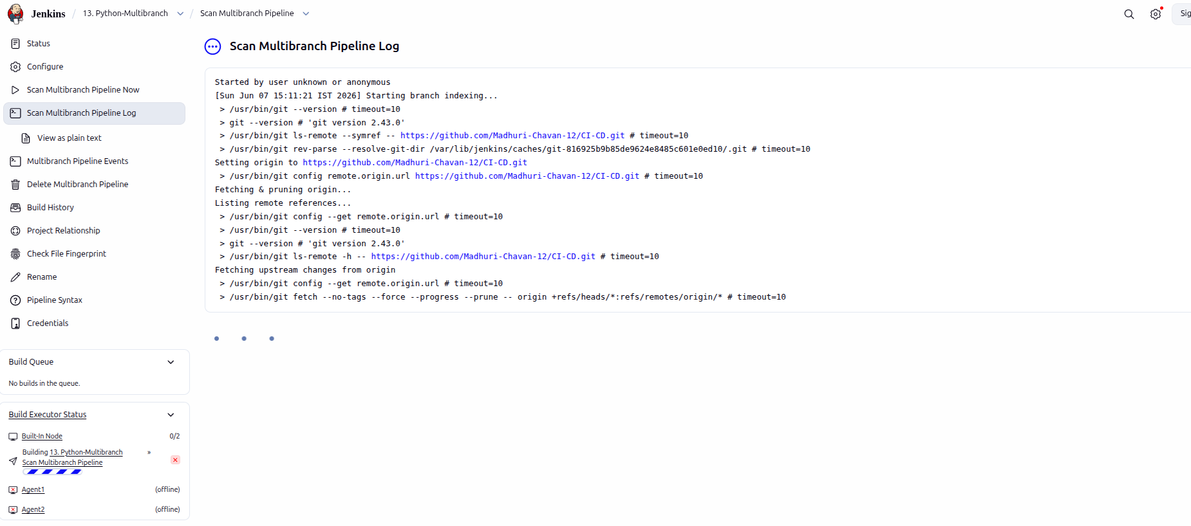

------------------------------------------------------------------------------------------

Step 9 : Run Build Automatically
dev branch changes .
git checkout dev
app.py
print("Multibranch Pipeline Working!")
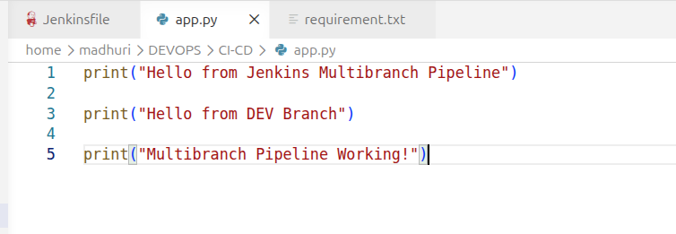
Push .
git add .
git commit -m "Testing Multibranch"
git push origin dev
